**Commodore PET/CBM 1541 Adapter Rev. 0**

**Module Description**

Table of Content

Introduction 1

Requirements 2

Instruction Set 3

Dimensions 4

RESET Switch – SW6 5

Connectors 5

Cassette Port Dongle 5

+5VDC Power 5

IEC-Bus (1541) 5

Jumpers 6

JP1 - User Port Connections 6

JP2, JP3 – Input Inversion 6

JP4 – Power Switch 6

Revision History 6

Rev. 0 6

# Introduction

This is a reconstruction of an unknown hardware, which fits to the software from an EPROM, that was discovered in a CBM8032. It is an adapter for a 1541 Floppy Disk Drive, which connects to the User Port of CBM computers like the 8032.

The IEC port only allows to connect a floppy disk drive with device number 8 (which does not interfere with a device number 8 on the IEEE-488 bus!). The instructions for accessing the 1541 are not standard instructions (but very similar). Thus, the 1541 cannot replace an IEEE-488 floppy disk drive, when it comes to accessing files (SEQ or SER) or saving a machine language/assembler program from a monitor like the TIM.

It is good for saving and loading programs on/from the 1541, showing the directory (non- destructive) or displaying the disk status.

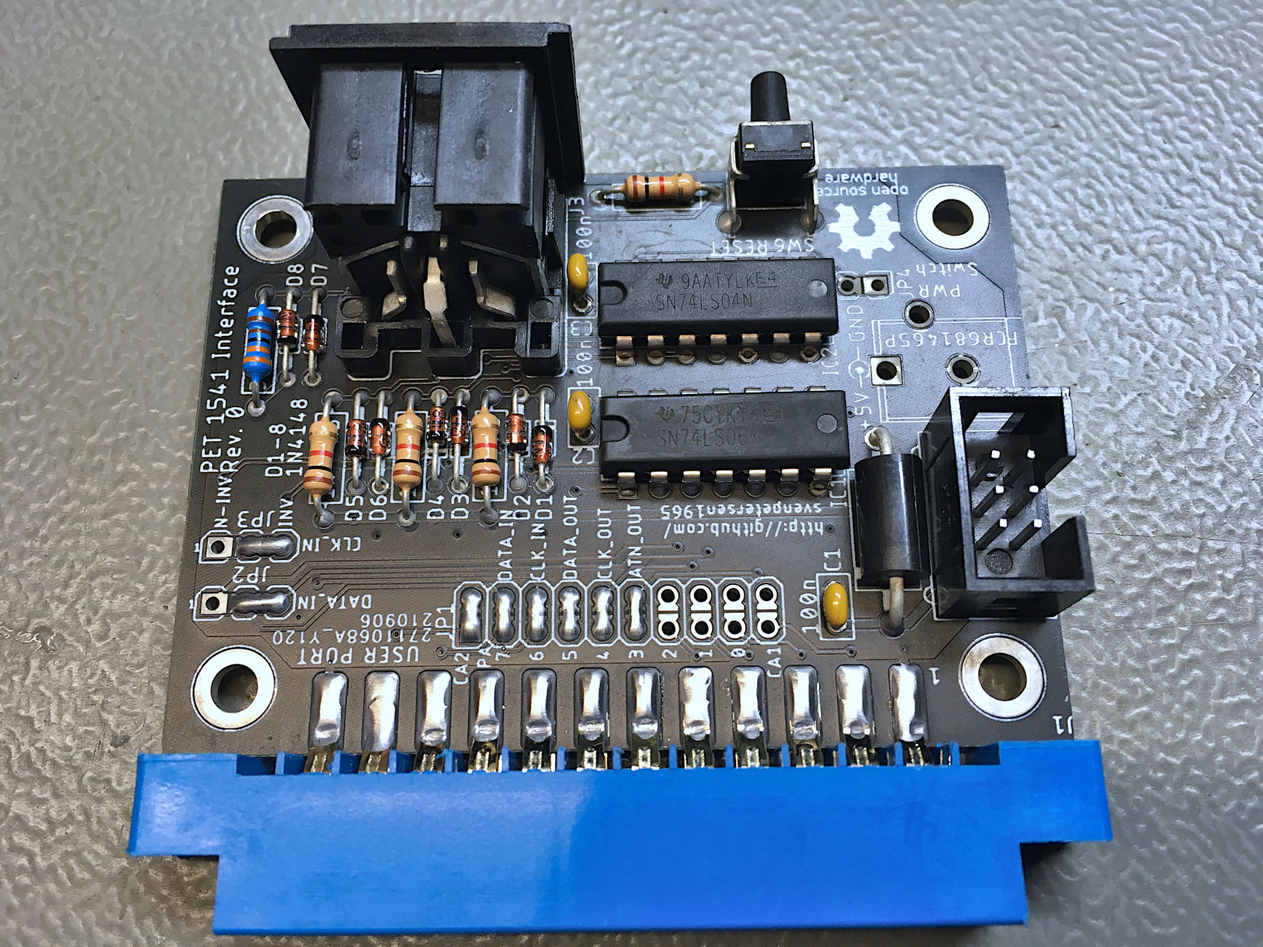

Figure 1: Standard assembly of the PET/CBM 1541 Adapter with the minimal required components

# Requirements

Since the User Port of the CBM and PETs does not provide a 5V supply voltage, it can be tapped at a cassette port dongle. It is recommended to use the C64 diagnostic harness cassette dongle for this purpose (it can be found here: <https://github.com/svenpetersen1965/C64-Diagnostic-Rev.-586220-Harness>). Further, the 6 pin ribbon cable of the previously mentioned project is required.

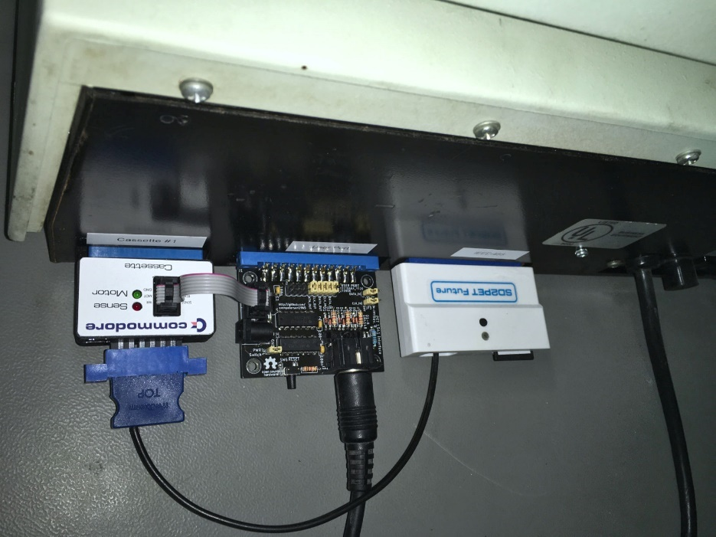

Figure 2: PET/CBM 1541 adapter with cassette port dongle (and an SD2PET) with a CBM8032

Also, the VC-1541-DOS/80 EPROM is required to be installed in the EPROM socket UD11.

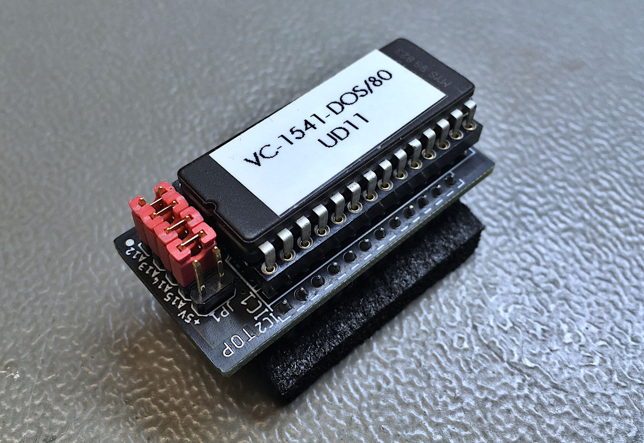

Figure 3: The Driver Software EPROM.

Originally, the driver software was burned in a TMS2532 4kB EPROM, which directly fits in the socket UD11 on the CBM mainboard. Since those are hard to get and not programmable with many EPROMmers, like the TL866, very likely, an adapter is required like shown in Figure 3.

# Instruction Set

The instruction set was derived from analyzing the binary of the driver software. The software is started with

SYS40960

The software will answer

vc-1541-dos/80

ready.

The instructions follow these rules:

* each instruction starts with '!'
* there are a couple of floppy disk related instructions, that have an alternative representation in the EPROM
* a !q will deactivate/quite the software
* a !@ will display the status of the 1541
* a !@"command" will send a command to the 1541
* No device number (,8) is required for any of the instructions
* The instructions are mostly standard BASIC4 instructions and can be short-cut as usually

|  |  |  |
| --- | --- | --- |
| Instruction | Format | Note |
| load | !load"progname" | loads a program from 1541 |
| save | !save"progname" | saves a program to 1541 |
| verify | !verify"progname" | verifies a program |
| catalog | !catalog | displays the driectory of the floppy disk in the 1541 |
| open | !open#SA,"file name" | it requires a # and after that it is a secondary address* |
| print# | !print#,"text" | prints a texts, also a secondary address after #* |
| get# | * | * |
| close | !close#SA | closes a file, also a secondary address after #* |
| input# | !input#SA...* | * |
| cmd | !cmd...* | * |

The items marked with * require some further investigation. See the test documentation.

The commands, which are usually sent to the 1541 via secondary address 15, can be sent with the !@ command.

|  |  |
| --- | --- |
| Command | Function |
| !@"s:file name" | Scratch the file <file name> |
| !@"n0:disk name,xx,yy" | Format disk |
| !@"i" | Initialize disk |
| !@"v" | Validate disk |
| !@ | Displays the disk status |
| […] | […] |

# Dimensions

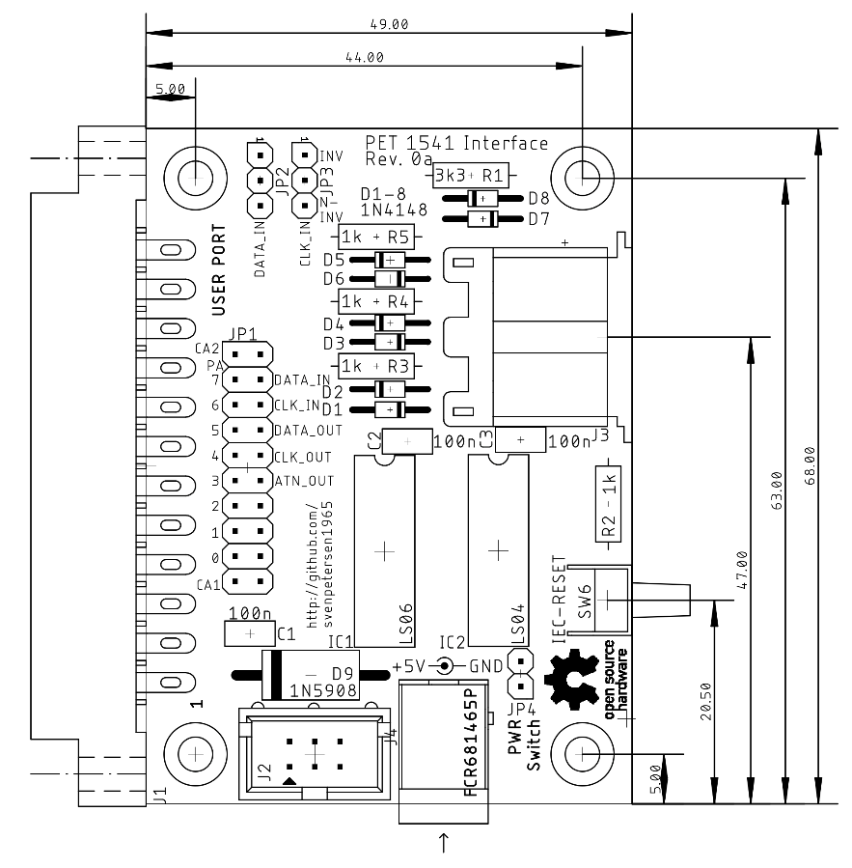

Figure 4: PCB Dimensions

# RESET Switch – SW6

The RESET Switch is a bus reset for the 1541 only. It does not reset the computer. It is a standard 90° TACT-switch.

# Connectors

## Cassette Port Dongle

J2 – 2x3 pin header for a ribbon cable connected to the cassette port PCB (project number 114).

|  |  |  |  |
| --- | --- | --- | --- |
| **Pin** | **Signal** | **Pin** | **Signal** |
| 1 | GND | 2 | +5V |
| 3 | n.c. | 4 | n.c. |
| 5 | n.c. | 6 | n.c. |

n.c.: not connected

## +5VDC Power

J4 - 5,5mm/2,5mm barrel connector

|  |  |
| --- | --- |
| Pin | Signal |
| Center | +5VDC |
| Shaft | GND |

This connector is optional and not required, if it is intended to power the interface from the cassette port dongle. To make use of it, JP4 has to be closed, which can be achieved with a jumper, a solder bridge or a (power) switch.

## IEC-Bus (1541)

J3 – Lumberg 010599 06, 6p DIN receptacles

|  |  |
| --- | --- |
| Pin | Signal |
| 1 | n.c. |
| 2 | GND |
| 3 | ATN |
| 4 | CLK |
| 5 | DATA |
| 6 | /RESET |

/RESET is a drive reset, not a PET reset.

# Jumpers

The jumpers show the experimental character of the prototype design. They can be fix settings and don’t need to be changed at any time. Thus, it is recommended to close them with a solder bridge as shown in Figure 1.

## JP1 - User Port Connections

|  |  |  |  |  |
| --- | --- | --- | --- | --- |
| Signal | Pin | Pin | Signal | Setting |
| CA2 | 1 | 2 | n.c. | Don’t care |
| PA7 | 3 | 4 | DATA_IN* | close |
| PA6 | 5 | 6 | CLK_IN* | close |
| PA5 | 7 | 8 | DATA_OUT* | close |
| PA4 | 9 | 10 | CLK_OUT* | close |
| PA3 | 11 | 12 | ATN_OUT* | close |
| PA2 | 13 | 14 | n.c. | Don’t care |
| PA1 | 15 | 16 | n.c. | Don’t care |
| PA0 | 17 | 18 | n.c. | Don’t care |
| CA1 | 19 | 20 | n.c. | Don’t care |

## JP2, JP3 – Input Inversion

|  |  |  |  |  |
| --- | --- | --- | --- | --- |
| Jumper | Pin 1 | Pin 2 | Pin 3 | Setting |
| JP2 | /DATA_IN | DATA_IN* | DATA_IN | Non-inverting (2-3) |
| JP3 | /CLK_IN | CLK_IN* | CLK_IN | Non-inverting (2-3) |

## JP4 – Power Switch

This Jumper can be used to connect a power switch or it can be closed. The +5V from the barrel connector are connected to the interface’s supply voltage with the jumper. The +5V from the cassette port dongle are always connected and do not require to be switched. JP4 is only required in conjunction with J3 (See chapter +5VDC Power).

# Revision History

## Rev. 0

* Fully functional prototype